Copyright Transfer Statement | 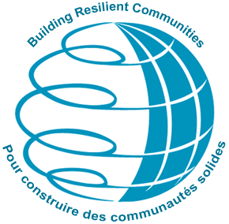

The copyright to this article is transferred to Institute for Catastrophic Loss Reduction (respective to owner if other than ICLR employees: to the extent transferable) effective if and when the article is accepted for publication. The author warrants that his/her contribution is original and that he/she has full power to make this grant. The author signs for and accepts responsibility for releasing this material on behalf of any and all co-authors. The copyright transfer covers the exclusive right to reproduce and distribute the article, including reprints, translations, photographic reproductions, microform, electronic form (offline, online) or any other reproductions of similar nature.

An author may self-archive an author-created version of his/her article on his/her own website and his/her institution's repository, including his/her final version; however he/ she may not use the publisher's PDF version. The author may only post his/her version provided acknowledgement is given to the original source of publication and a links are inserted to the published article on Symposium and ICLR websites. The link must be accompanied by the following text: "The original publication is available at www.flood2008.org and www.iclr.org ".

After submission of this agreement signed by the corresponding author, changes of authorship or in the order of the authors listed will not be accepted by ICLR.

4th International Symposium on Flood Defence

Title of article:

Author(s):

Corresponding author's signature:

Date:

Please return this form to:
Tracy Waddington, Manager, Administration
Institute for Catastrophic Loss Reduction
20 Richmond Street East, Suite 210
Toronto, Ontario M5C 2R9
Canada
Fax: 416 364 5889

